

National College of Ireland

BSc (Honours) in Computing - Evening

Software Development

2024

Paul Norton

X01420442

X01420442@student.ncirl.ie

Wild Gardens

Technical Report

Contents

Executive Summary 1

1.0 Introduction 3

1.1. Background 3

1.2. Aims 3

1.3. Technology 3

1.4. Structure 3

2.0 System 4

2.1. Requirements 4

2.1.1. Functional Requirements 4

2.1.1.1. Requirement 1 “Create Account” 5

2.1.1.2. Requirement 2 “User Movement” 6

2.1.1.3. Requirement 3 “Interact with Plants” 7

2.1.1.4. Requirement 4 “Display Information 9

2.1.1.5. Requirement 5 “Change Area” 10

2.1.2. Data Requirements 11

2.1.3. User Requirements 12

2.1.4. Environmental Requirements 13

2.1.5. Usability Requirements 14

3.0 References 15

4.0 Appendices 16

4.1. Project Proposal 16

4.2. Reflective Journals 23

# Executive Summary

This report outlines the development of Tiny Gardens, a peaceful educational game created using the Godot Engine. The project demonstrates core game design principles while leveraging Godot’s strengths in cross-platform development and open-source flexibility.

The game targets the PC and Android audience and emphasizes on peaceful world exploration and education. Key features include:

* A world to explore that contains several regions filled with secrets to find
* The ability to tend to a range of plants to aide in plant growth
* Facts and interesting information about plants to be presented to the user as the progress through the game.

This project serves as a practical exploration of game development learned through Godot and gdscript. Challenges such as world building, animations, and functioning code were addressed through iterative testing and Godot’s built-in tools.

The final deliverable will include a playable build, source code, and documentation, showcasing my ability to translate design concepts into a functional game.

# Introduction

## Background

This project was chosen as it is a way to demonstrate what has been learned with the Godot Engine through the online courses, while also having representing similar aspects to the original project concept back in 2019.

## Aims

The aims of this project is to provide the user with a peaceful, educational game that would allow the user to relax, explore a peaceful environment, tend to plants in the wild which would present the user with interesting facts about the plants.

## Technology

Godot Engine will be used for the coding in creation of the project; Godot is a free object based platform that uses its own version of Python which is called GDScript.

Android studio will be implemented to allow the user to interact with the program on their phones instead of a computer.

Googles Firebase will be used to create a user login/register system as well as potentially allow the user to access their saved data across multiple devices.

## Structure

This document will first look at the system requirements going through each requirement of the UCD and how they should function, which will be followed by the requirements of the data, user, environment, and usability. It will show how the design is implemented along with the GUI. The methods of how the application was tested. Finishing with the final thoughts of the project and how the application can be developed further, ending with the appendices.

# System

## Requirements

## Functional Requirements

This section lists the functional requirements of the Tiny Gardens project. Below is the user case diagram outlining the several use cases that will be explained in greater detail in the section further below.

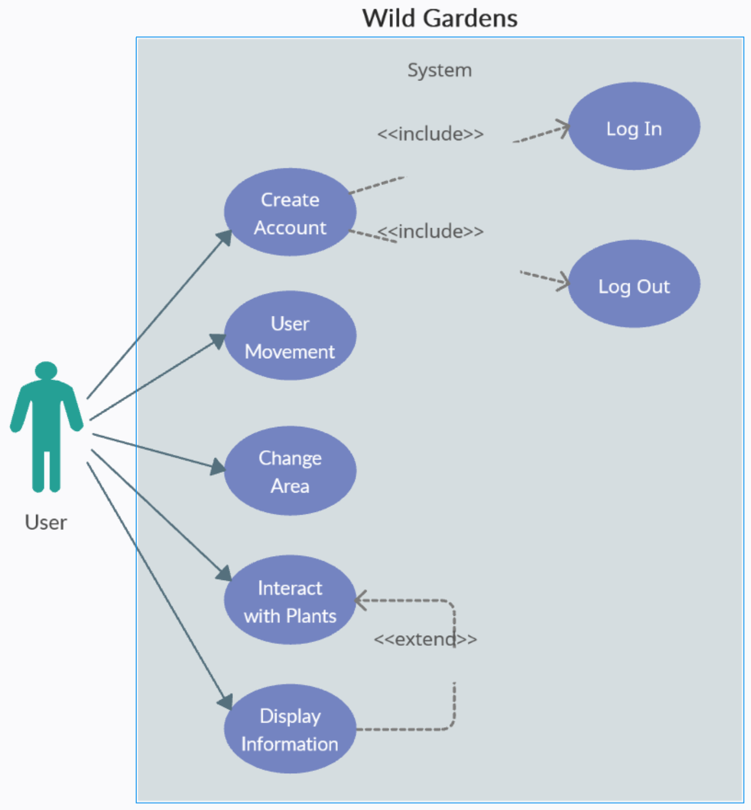  
Use Case Diagram

## Requirement 1 “Create Account”

**Description & Priority**

The user must be able to create an account for the game which includes being able to register an account and being able to log into the account to access the program.

**Flow Description**

**Precondition**

The user must have access to the application

**Activation**

This use case starts when the user opens the application

**Main flow**

1. The user enters an email and password
2. The user attempts to validate their details
3. The users details are validated
4. The users account is created on the server
5. The user is asked to log into the account

**Alternate flow**

A1 : Invalid user details

1. The use case starts at M2
2. The details are invalid
3. The system alerts the user
4. The user is asked to enter new details
5. The use case continues at M1

**Termination**

The user has successfully created an account

**Post condition**

The user may now log into the application

## Requirement 2 “User Movement”

**Description & Priority**

The user must be able to navigate the world with the character, being able to move in all directions and have collision with the world boundaries and other objects within in the world.

**Flow Description**

**Precondition**

The user has logged in

**Activation**

The user has entered the game

**Main flow**

1. The user presses a directional key
2. The character model turns to that direction
3. The character model moves in that direction
4. The user navigates to a certain spot in the area
5. The character model moves to that spot
6. The user stops moving
7. The character model stops moving

**Exceptional flow**

E1 : Character model hits a collision object

1. The use case starts at M3
2. The character model encounters a collision object
3. The character model is unable to move in that direction any further
4. The character model stops
5. The use case continues at M1

**Termination**

The user has stopped moving the character

**Post condition**

The character model is at the user chosen location

## Requirement 3 “Interact with Plants”

**Description & Priority**

The user must be able to interact with plants in the world, be able to progress the growth stages of the plants in order to fully develop the plant to unlock plant information

**Flow Description**

**Precondition**

The user has found a plant within the application

**Activation**

The user interacts with the plant

**Main flow**

1. The plant displays information depending on its level
2. The user waters the plant
3. The plant checks its watered status
4. The plant checks its level
5. The plants level goes up by 1
6. The plant displays new information depending on its level.
7. The user walks away from the plant

**Alternate flow**

A1 : The user chooses not to water the plant

1. The use case starts at M1
2. The user does not water the plant
3. The use case continues at M7

**Exceptional flow**

E1 : Plant has already been watered today

1. The use case starts at M3
2. The plant has already been watered today
3. The user is notified
4. The plant level stays the same
5. The user case continues at M7

E2 : The plant is at max level

1. The use case starts at M4
2. The user is notified
3. The plant level stays the same
4. The user case continues at M7

**Termination**

The user walks away from the plant

**Post condition**

The system waits for user interaction, the plant may have gained a level

## Requirement 4 “Display Information

**Description & Priority**

The user must be presented with information about the plants at certain stages of the plants level development.

**Flow Description**

**Precondition**

* The user has discovered a plant within the game
* The user must have a minimum level of the plant

**Activation**

The user interacts with a plant

**Main flow**

1. The plant checks its current level
2. The plant displays unlocked information to the user
3. The user is presented with the unlocked information
4. The user walks away from the plant

**Alternate flow**

A1 : Plants level is maxed out

1. Use case starts at M1
2. The plant level is maxed out
3. The System records plant as max level unlocked
4. The plant displays all available information
5. The user is notified of plant completion status
6. Use case continues at M4

**Exceptional flow**

E1 : Plants level is too low

1. Use case starts at M1
2. The plant level is too low to unlock and information
3. The plant displays no information
4. The user is notified of no level progress
5. Use case continues at M4

**Termination**

The user walks away from the plant

**Post condition**

The system waits for user interaction

## Requirement 5 “Change Area”

**Description & Priority**

The user must be able to interact with map changing points that will allow the user to access additional areas to explore, a requirement to access these areas is the progress of plants within the current area.

**Flow Description**

**Precondition**

* The user is able to explore the area
* The user has a certain plant level unlocked

**Activation**

The user approaches a map changing location

**Main flow**

1. The player model interacts with the area change gate
2. The gate checks to see what level the current areas plants are
3. The gate allowed the player to access the new area
4. The current game scene ends
5. The new game scene is loaded
6. The player model appears just outside the new areas gate
7. The player model walks away from the gate

**Exceptional flow**

E1 : The plant level is not high enough

1. The use case starts at M2
2. The plant is not a high enough level
3. The user is notified
4. The gate remains unusable
5. Continue at M7

**Termination**

The user leaves the area change gate location

**Post condition**

The user is within a new area within the application

## Data Requirements

**Data Input**

The game will accept user interactions through the mouse and keyboard with potential interactions through a mobile devices touch screen. The user will use the WASD key or mouse right click to navigate the game world while using the E and F keys, or left click to interact with objects. The ESC key will bring the user to the menu screen. The key binds may be customizable with the commands being stored to a config.ini file.

**Data Output**

The user will have the option to save their progress within the game along with the option to restore this save file. On the start of a new in game day or when the user manually presses the save button the information stored on the global.gd file will be save to savegame.bat file. On reloading the information on the savegame.bat file will be transferred to the global.gd file within the game, this will allow the user to continue where they left off.

**Storage & Databases**

User account information will be stored and accessed through Googles firebase online server system. This will also allow for potentially save game information to be stored within the server too to allow users to carry progress from one device to another.

**Compliance & Security**

Outside of username and password no personal information will be collected about the individual user. Protection maybe added to save files that will trigger an integrity check should a save file be modified.

## User Requirements

**Player Profile & Progression**

The game will store the players save data to allow user progression. This data will contain information such as various plant stage levels, characters position last loaded map, a list of found collectables, current day and weather pattern.

**Core Gameplay Mechanics**

The player will be able to explore and interact with the game world using the mouse and keyboard. They will be find plants within this world and will be able to tend to the plants in various ways such as watering, this will allow the plant to grow stronger and in doing so will present the player will facts and information about the tended plant that the player can access to learn.

**Content & Replayability**

As the game is designed as a relaxing, education game; it is created for the user to play on a daily bases so that users can take their time and not feel rushed to complete the content in a single sitting.

Due to the scalability of the game new areas, plants, collectables and secrets can be added easily to insure new content can be added to the game on a regular bases.

## Environmental Requirements

**Hardware and Software Requirements**

Godot is fairly lightweight, making it compatible with older hardware, particularly for basic projects. However, system requirements may increase with more complex projects, especially in 3D. For mobile platforms, running a Godot application requires OpenGL ES 3.0 support.

Minimum Requirements:

Operating System: Windows 7 or newer, macOS 10.12 or newer, or a recent Linux distribution. Processor: Support for OpenGL 2.1.  
Memory: 2 GB of RAM.

Recommended Requirements:

Operating System: Windows 10 or newer, macOS 10.12 or newer.  
Processor: Support for OpenGL 3.3.  
Memory: 4 GB of RAM.

**Peripheral Support**

A keyboard and mouse will be required to for the player to interact with the game, for mobile devices a functional touch screen will be required.

## Usability Requirements

**Learning Curve & Tutorials**

At the initial loading into the game the player will be presented with a list of the controls, how to play the game, and what the objective is for the game. At certain locations the game will prompt the player with hints and suggestions on how to progress

The user will have the ability to review this tutorial again through an option on the main menu.

**UI/UX Clarity**

Any prompts, changes, or critical information needed will be displayed to the user as text information on the screen.

Buttons and options shall be labeled clearly to insure the player is aware of what there outcome will be.

**Player Customization**

Players will have the option to choose a character model they feel is a better style of how they would like to play.

**Error Prevention & Recovery**

The game will auto save the players progress at the start of each new day.

To prevent the player from accidently deleting their save file they will be prompted with a confirmation button to confirm their request to delete the same file.

# References

**Tilesets**

Game Endeavor, **“Mystic Woods - 16x16 Pixel Art Asset Pack”**. Available at:  
 https://game-endeavor.itch.io/mystic-woods, Accessed: March 2025.

Josie Makes Stuff, **“Pixel art Farming assets”**. Available at: https://josie-makes- stuff.itch.io/pixel-art-farming-assets, Accessed: April 2025.

Brysiaa, **“Pixel flowers stages of blooming [16x16 px]”**. Available at: https://www.deviantart.com/brysiaa/art/Pixel-flowers-stages-of-blooming-16x16-px- 856070750, Accessed: April 2025.

ToffeeCraft, **“Pixel Bunny Mega Pack Demo”**. Available at: https://toffeecraft.itch.io/bunny-pixel-animations-mega-pack, Accessed: April 2025.

**Software**

Godot Engine (2023) ***Godot Engine 4.2.0*.** [Software]. Godot Foundation. Available at: https://godotengine.org, Accessed: September 2024.

# Appendices

## Project Proposal



National College of Ireland

Project Proposal

Wild Gardens

17/12/2024

BSc (Honours) in Computing - Evening

Software Development

2024

Paul Norton

X01420442

X01420442@student.ncirl.ie

Contents

1.0 Objectives 2

2.0 Background 3

3.0 State of the Art 3

4.0 Technical Approach 4

5.0 Technical Details 4

6.0 Special Resources Required 4

7.0 Project Plan 5

8.0 Testing 6

Objectives

The project I would like to develop for my course would be that of an educational and mental wellness game that is designed to provide information and facts about plants that the user would interact with in the world of the program as well as offer a peaceful setting that the user could use to potentially help with stress. This idea stemmed from my original project idea back in 2020 where the user could use image recognition on their phone to identify plants and would then be provided with historical facts and details about the scanned plant.

In this new idea the user would explore an open park like setting where they would come across plants that would be initially in a poor condition, the user would then visit and tend the plants daily which would improve the plants through several stages until the plants was fully healthy, with each stage of the plants health providing images, facts, and historical data about the plant.

Depending on how the project develops there are several ways for the project to be expanded and scaled up:

* A much larger variety of plants and flowers can be added to the program along with more stages of plant growth.
* A range of random mini games could be added as the method of interacting with the plant to help its growth.
* Additional themed regions can be added for the user to explore with a whole new range of plant life that would be native to that region such as forests, riverside/lakeside, hills and mountains.
* A weather or seasonal system can be implemented which would affect which plants are available to be interacted with.
* Personalized customisation could be implemented which would allow the user to create the character they would use through the game.
* A garden can be added where the plants the user has completed could grow to show the progress the user has made.
* Wildlife may be added to add some additional exploration and user interaction.
* There is the potential to add hidden secrets and collectables throughout the game world.

The project its self would be developed using the Godot engine which uses a variation of Python called gdscript which is something I have begun to study in my free time using online courses and tutorials.

Background

Back in 2019/2020 I had an idea for a project that would involve using your phones camera to identify local plant life using image recognition. The app would allow the user to take a photo of the plant and then compare the image to a database of plant images to identify what the plant was and then provide the user with a list of facts and history about the plant but this project was never completed.

Presently I have been doing online courses to learn Godot, which is a game development engine and I have chosen to mesh both what I’m learning and my original project idea into my final project for this year by taking the plant identification and education aspects from the original project and using the game play aspects of what I’m learning in Godot to create an education game where the user will explore the games setting and discover plants to interact with to learn interesting facts about these plants.

State of the Art

There are two similar games that I feel gave me inspiration for the game aspect of this project.

The first game would be ‘Stardew Valley’, which has a charming astatic and sees the user grow crops and plants on their farm in order to make money to build a home; it also involves exploring a village and surrounding area and has combat situations where the player needs to defeat monsters for other loot and items. The inspiration this game offered for my project idea was the exploration aspect was the user could wander around a setting to find plants to grow and develop.

Where Stardew Valley would differentiate from the project would be that the user wouldn’t be required to farm crops for money or build a home, nor would there be other characters or a village to interact with, and there would also be no combat as this is meant to be a peaceful and educational experience.

The second game that would be similar to the project idea is a mobile app called ‘Kinder World’. This app is a meditative and mindfulness app where the user chooses a plant to grow, nurtures the plant every day which results in the plant growing more leaves and the user receiving a motivational text to help the user.

This app is similar in that the user would take care of plants daily which would hopefully be a peaceful experience for the user. The ways that it would be different is the user would explore and find the plants in a natural environment instead of a plant pot, as well as be presented with information and facts about the plants.

Technical Approach

The project will be coded within the Godot engine using gdscript which is a variation of python.

The project will require an area that will contain the user and the flowers. This area will be called a scene and will be designed using a tileset which will set the boundary for the user to explore.

The user to be required to move around this scene to explore the area, this will be done by using directional movement functions.

The user will need to interact with flowers throughout the level. This will require the user to approach the flower to create a user prompt to interact with.

Technical Details

The main principal library will be Godot Engine which is a lighter-level library which is a popular 2D and 3D game engine with a powerful editor and Lua/GDScript support. GDSCript is the language used within Godot and is a variation of the Python language.

Special Resources Required

The project will be developed using the Godot game engine; this means access to the engine will be required. As Godot is an open-source engine available at no cost, there should be no issues in coding the project.

For deployment, the application is intended to be ported to the Android platform using Android Studio. This development environment is also freely available to use.

For complexity a user login and registration system will be implemented using Googles Firebase Servers.

Regarding in-project assets, the development will require tilesets and graphical elements. These resources can be sourced from various online repositories offering extensive free options. Additionally, premium asset packages will be considered should expanded functionality or higher-quality visuals be required.

Project Plan

This document outlines the key stages of the project, including the planned actions and their respective timelines. Below is a graph with a visual representation of the projects timeline

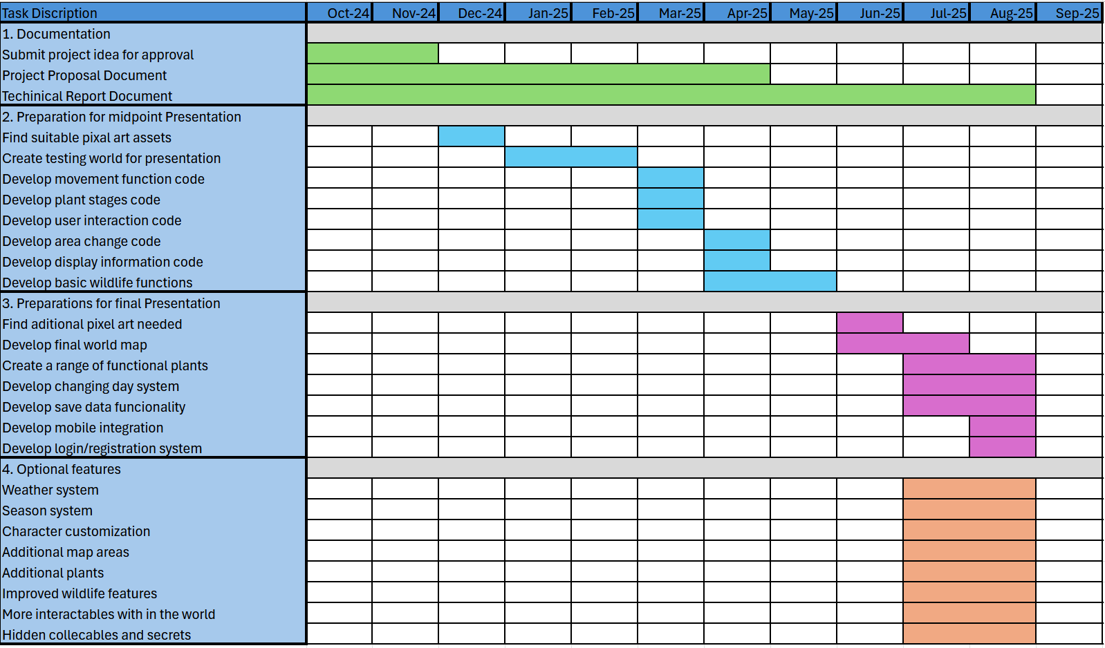

The project plan is organized into four distinct phases to ensure a structured and systematic approach to execution.

1. **Documentation Preparation**  
   The initial phase focuses on compiling and finalizing all necessary project documentation, including requirements, design specifications, and supporting materials to establish a clear foundation for development.
2. **Midpoint Presentation Preparation**  
   The second phase outlines the key deliverables and components required for the midpoint presentation.
3. **Final Project Completion**  
   The third phase encompasses the remaining development tasks necessary to deliver a fully functional and polished final product. This stage ensures all core objectives are met and the project is ready for conclusive evaluation during the final presentation.
4. **Optional Features**  
   The final section identifies optional features that could further enhance the application’s functionality or user engagement. These additions will be prioritized and implemented only if time and resources permit.

Testing

As this project will take the form of an interactive game only some features of this project would benefit from unit tests. Overall the standard method for testing in small games would be user testing and QA’s by laying down a test plan that would cover all aspects of the game.

There are several methods of doing these tests:

Gameplay Testing. Making sure all the features work as intended and how each of the features would interact in different ways.

Destructive Testing. Trying to break the code and the game by doing this you know shouldn’t work in the hopes of causing errors.

Monkey Testing. Randomly trying different ideas and commands in the hopes of find some unknown issue or unexpected result.

Performing these tests may help in finding some issues but to fully get the benefits of a user test I would need testers to test the game for me, these people would have no expectation of how the code would work and would try combinations of tests that I might have felt were too obvious to try.

This would also offer the added bonus of the opportunity to receive user feedback on the state of the game that would help me decide what direction to take future updates.

## Reflective Journals

**October**

**Supervision & Reflection October**

|  |  |
| --- | --- |
| **Student Name** | Paul Norton |
| **Student Number** | X01420442 |
| **Course** | Computing Project (BSHCCYBE4) |
| **Supervisor** | Anshu Shahdeo |

**Month: October**

|  |  |
| --- | --- |
| **What**?  This October I have thought of a project idea and have presented it to my supervisor Anshu who seemed to think it was a good idea for my project. | |
| **So What?**  With a project in mind it gives me a chance to start thinking of how I would start implementing this project as well as come up with additional ideas that would add some complexity to the project. | |
| **Now What?**  The next task is to sit down with Anshu and go over the ideas to see which would be beneficial to my project and to see where to start laying out the ground work. | |
| **Student Signature** | Paul Norton |

**November**

**Supervision & Reflection November**

|  |  |
| --- | --- |
| **Student Name** | Paul Norton |
| **Student Number** | X01420442 |
| **Course** | Computing Project (BSHCCYBE4) |
| **Supervisor** | Anshu Shahdeo |

**Month:**

|  |  |
| --- | --- |
| **What**?  This month I thought about the future aspects of my project idea and how it could be developed in the future. I thought if some fun additional features I could add to demonstrate my abilities and to expand on how the project could work as a show case piece.  I also focused on completing sections of the proposal Plan so that I could get a start on it. | |
| **So What?**  I still need to brainstorm some solutions for the potential new features, and my Proposal still needs to be completed. I would also need to start looking up art styles for my project. I have an idea of how I would like it to look but I need to find suitable graphics and textures. | |
| **Now What?**  The next task is to start putting the project together and try making a working prototype that can be demonstrated along with finishing off the Project Proposal. | |
| **Student Signature** | Paul Norton |

**February**

**Supervision & Reflection February**

|  |  |
| --- | --- |
| **Student Name** | Paul Norton |
| **Student Number** | X01420442 |
| **Course** | Computing Project (BSHCCYBE4) |
| **Supervisor** | Anshu Shahdeo |

**Month: February**

|  |  |
| --- | --- |
| **What**?  This month I didnt get as much done as I would have liked. I managed to set up a Github for the project and I looked at some tilesets for the visual aspects of my project. | |
| **So What?**  I still need to sit down and start creating the project as I feel I’m starting to fall behind. | |
| **Now What?**  For February I would like to start the project and get some of the basic functions done so that they could be documented and graphed. | |
| **Student Signature** | Paul Norton |

**March**

**Supervision & Reflection March**

|  |  |
| --- | --- |
| **Student Name** | Paul Norton |
| **Student Number** | X01420442 |
| **Course** | Computing Project (BSHCCYBE4) |
| **Supervisor** | Anshu Shahdeo |

**Month: March**

|  |  |
| --- | --- |
| **What**?  Truthfully, not a lot was done during this month due to procrastination. | |
| **So What?**  The project still needs to started and work needs to be done on the documentation. | |
| **Now What?**  I would like to start a prototype for the project and create several usecases that are needed in the report | |
| **Student Signature** | Paul Norton |

**April**

**Supervision & Reflection - April**

|  |  |
| --- | --- |
| **Student Name** | Paul Norton |
| **Student Number** | X01420442 |
| **Course** | Computing Project (BSHCCYBE4) |
| **Supervisor** | Anshu Shahdeo |

**Month: April**

|  |  |
| --- | --- |
| **What**?  This month I got to sit down and work on my project. I created a lot of the ground work code for things such as the player and the environment so that it will be easier to expand and build. | |
| **So What?**  Created a contained area to demonstrate functions during the mid point presentation along with how the player will interact with the environment. | |
| **Now What?**  There are still some basic functions I would like to have sorted before the mid point presentation and I need to really dig into the documentation and get that written up before the due dates. | |
| **Student Signature** | Paul Norton |